**Name -Monika Gariya**

**Email-** [**monikagariya2023@gmail.com**](mailto:monikagariya2023@gmail.com)

**Data Engineering Batch 1**

**Date – 27-02-2024**

**TOPIC- Azure Synapse Analytics Practical Implementation**

**What is Azure Synapse Analytics?**

Azure Synapse Analytics is an enterprise analytics service that accelerates time to insight across data warehouses and big data systems. It brings together the best of SQL technologies used in enterprise data warehousing, Apache Spark technologies for big data, and Azure Data Explorer for log and time series analytics.

**Features of Azure Synapse**

1. Limitless scale to rapidly deliver insights from all your data across data warehouses and big data analytics systems
2. Powerful insights uncovered from all your data transformed with machine learning models to enhance your intelligent apps
3. Unified experience for developing end-to-end analytics solutions to significantly reduce project development time
4. The most advanced security and privacy features on the market, including column- and row-level security and dynamic data masking

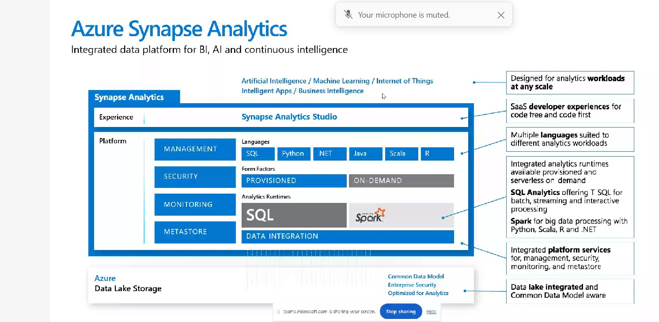

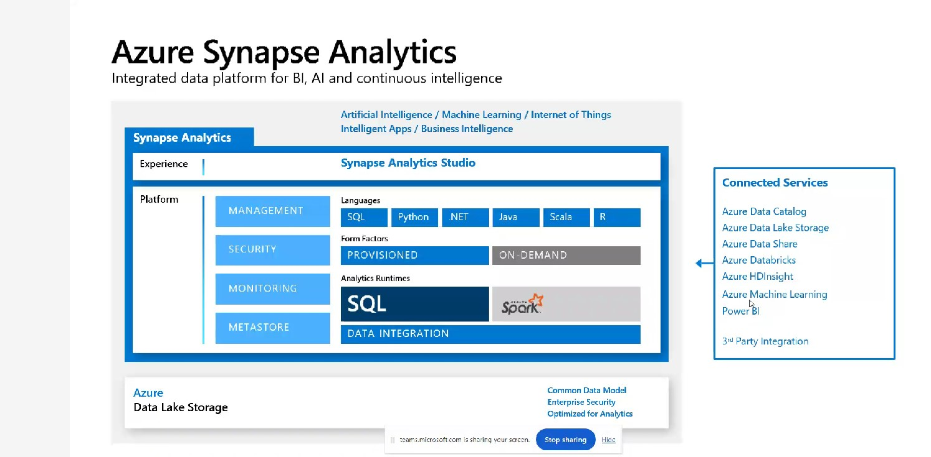

## ****Steps To Create An Azure Synapse Analytics Instance Using Azure Portal****

**Prerequisites:** Create an Azure Free Trial Account. You can also refer to our blog on how to create an [**Azure Free Trial account**](https://k21academy.com/microsoft-azure/create-free-microsoft-azure-trial-account/).

**Step 1:** Sign in to the **Azure Portal**.

**Step 2:** Click on the **Create a Resource** option to add a new resource.

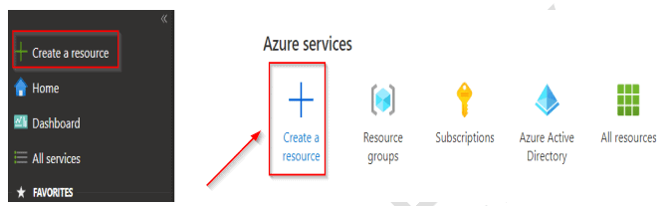

**Step 3:** In the search bar type **Synapse** or **Azure Synapse Analytics (formerly SQL DW)**and click on**Create.**

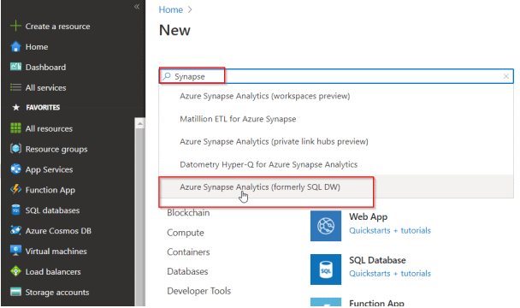

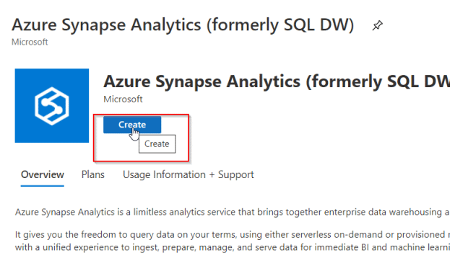

**Step 4:** In the **New Synapse Analytics**screen (if you do not have an existing resource group, then you can create a new one), fill out the details, and then click on **Create**:

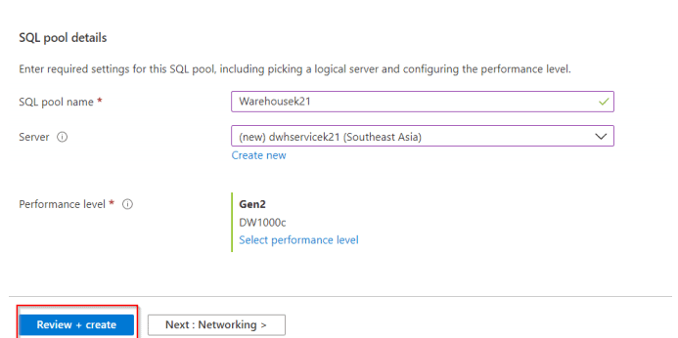

After the account is deployed, you can click on **Go to resource** and start uploading data and performing queries on it.You can configure the server firewall by selecting the server from the resource group tab and clicking on the Firewalls and Virtual Network tab.

